|  |
| --- |
|  |

|  |  |
| --- | --- |
| National Park Service  U.S. Department of the Interior  Pacific Island Network |  |

Standard Operation Procedure:

**Preparing YSI Files for Importing into the Database**

Version 1.1

Change History

|  |  |  |  |  |  |
| --- | --- | --- | --- | --- | --- |
| New Version # | Revision Date | Author | Changes Made | Reason for Change | Previous Version # |
| 1.1 | 7/18/18 | Kelly Kozar | Updated instructions for processing YSI files in the KOR Software | The KOR software has changed and the instructions in this SOP no longer apply | 1.00 |
|  |  |  |  |  |  |
|  |  |  |  |  |  |
|  |  |  |  |  |  |
|  |  |  |  |  |  |

Only changes in this specific SOP will be logged here. Version numbers increase incrementally by hundredths (e.g., version 1.01, version 1.02) for minor changes. Major revisions should be designated with the next whole number (e.g., version 2.0, 3.0, 4.0). Record the previous version number, date of revision, author of the revision, identify paragraphs and pages where changes are made, who approved the revision, and the reason for making the changes along with the new version number.

Recommended Citation:

Pacific Island Network (PACN). 2018. Preparing YSI Files for Importing into the Database. Pacific Island Network, National Park Service. Hawaii National Park, HI.

Purpose

This standard operation procedure gives detailed instructions on how to upload data from the YSI 6600V2 and YSI EXO2 Multi-parameter Water Quality Sondes and format the files so they can be imported into the Water Quality Monitoring Database.

YSI EXO2 Data Sonde

KOR-EXO Settings

In the KOR-EXO software, update the settings before opening the data files for the first time.

Click on the File tab in the KOR EXO main screen.

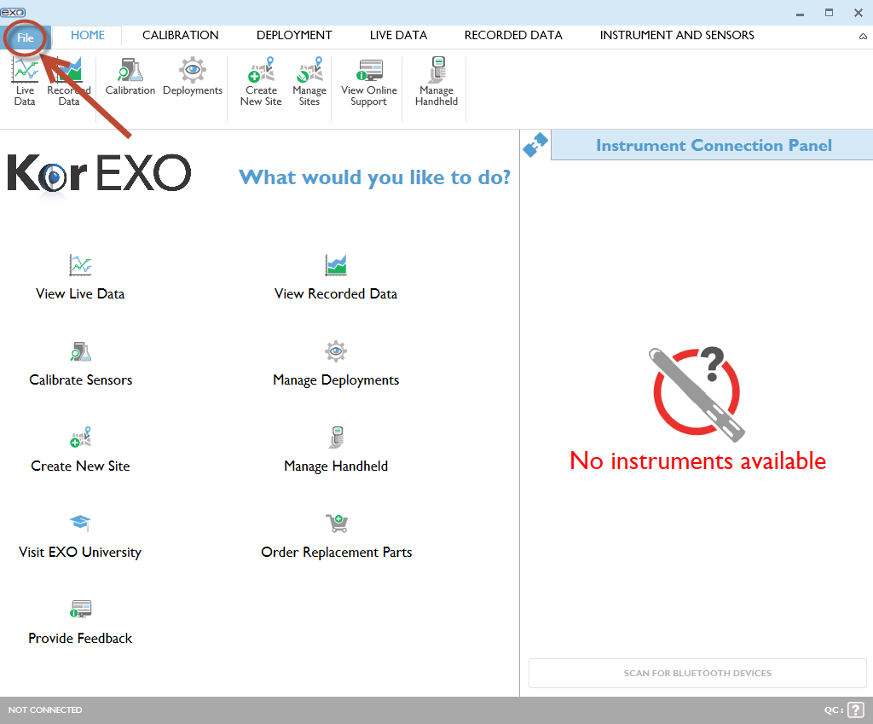

Click on Settings on the left hand side.

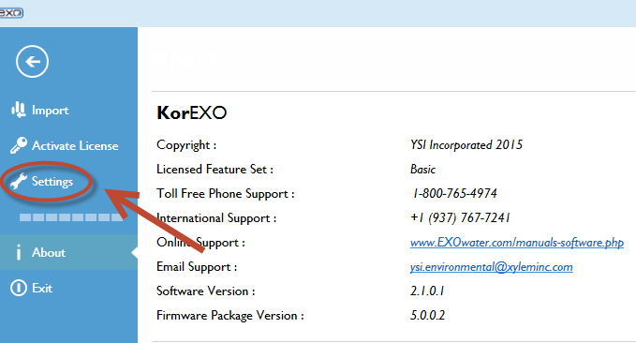

Under the General Settings tab, make sure you select as "Use "," as delimiter" for the CSV Delimiting field and the CSV Export type as "With Header".

Also update the Default Export File Directory to I:\vital_signs\13_water_quality\Data\Raw_Data\3_YSI\2018 so that you do not have to browse to that folder every time you export data. Leave the other fields with the default information.

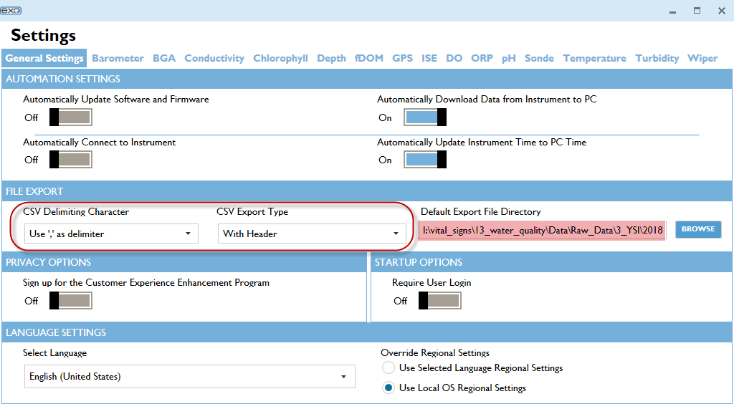

Choose from the parameters across the top of the Settings screen to set defaults for each parameter. Click on each successive parameter and make sure only the check boxes for the following parameters are clicked. *All other parameters should be marked as disabled*, so make sure to click on each of the parameter buttons and disable any parameters not listed below. Click Save when done.

* **Barometer – psi**

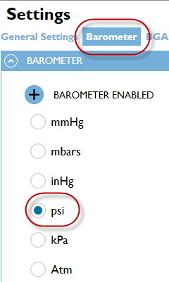

* **BGA – µg/L**

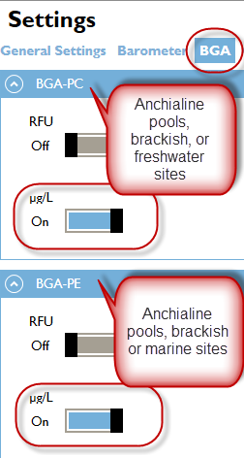

* **Conductivity – Specific Conductivity (mS/cm) and Salinity (ppt)**

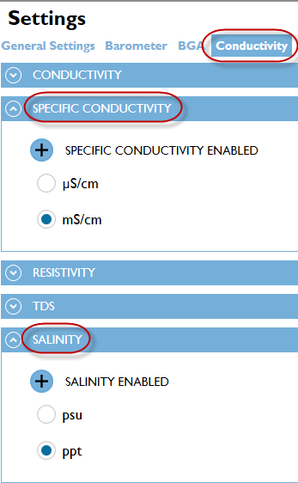

* **Chlorophyll – µg/L**

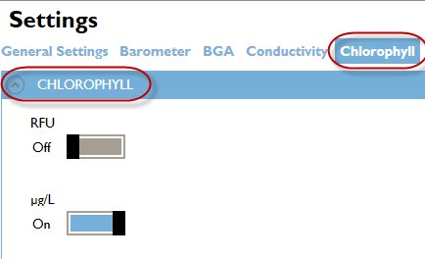

* **Dissolved Oxygen - %Sat and MG/L**

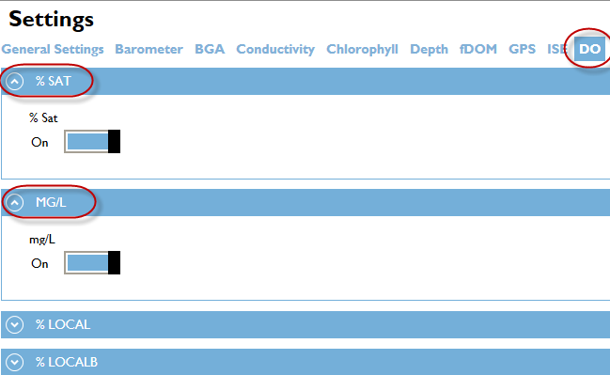

* **pH**

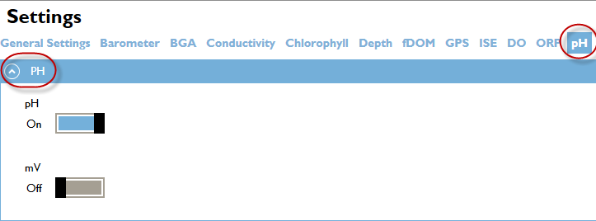

* **Temperature - Cº**

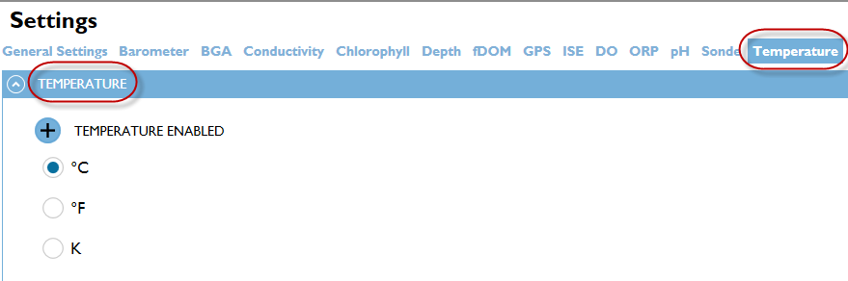

* **Turbidity – FNU**

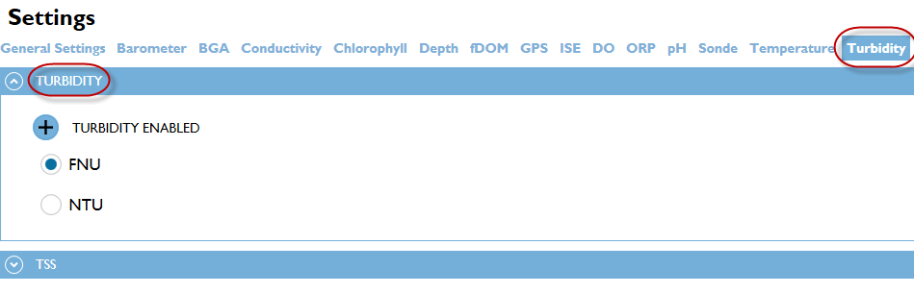

Exporting Data from KOR EXO

*Import binary file*

To export data to a .csv file open the .bin file that was uploaded from the YSI EXO2 sonde by importing it into KOR EXO.

Click on the File tab in the KOR EXO main screen.

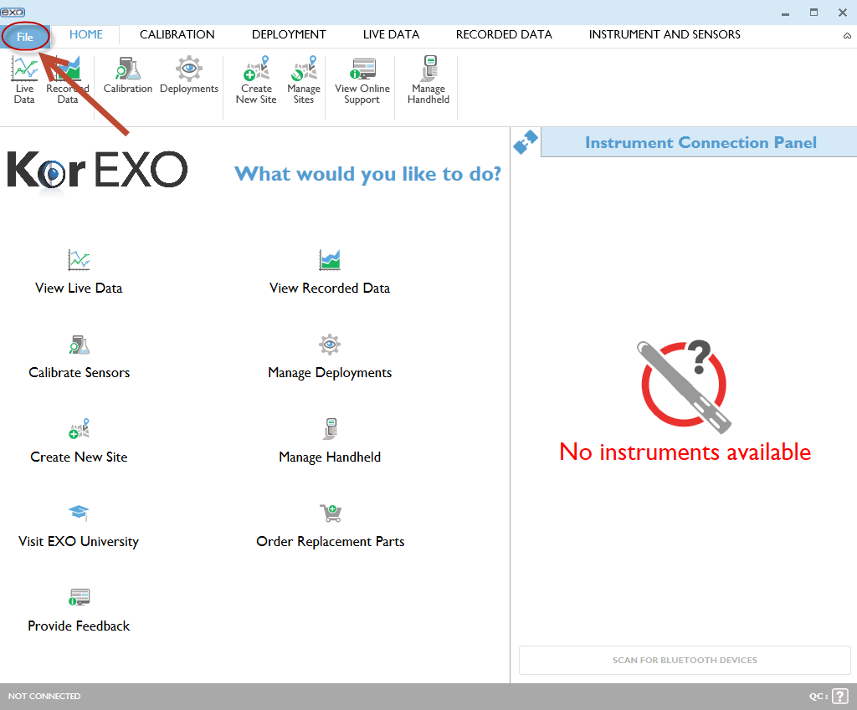

Click on Import on the left hand side.

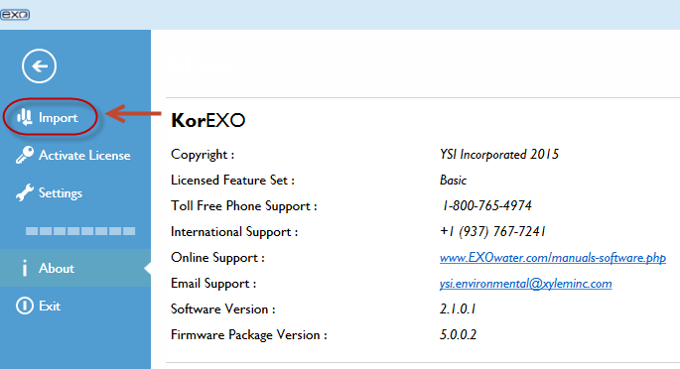

Click on IMPORT EXO BINARY FILE.

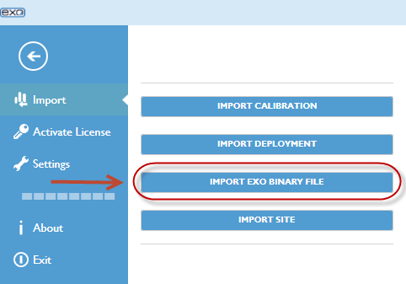

Navigate to the binary file that you would like to import. Click Open. Repeat this process until all the binary files for a sampling event are imported. Alternatively, you can simultaneously click the control and A buttons (ctrl + A) to select all files in the folder and import multiple files at a time. Make sure to see “All files uploaded successfully” after import.

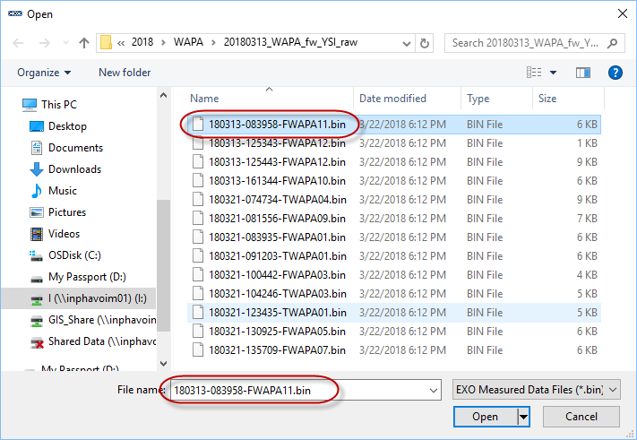

Click the back arrow button to return to the KOR EXO main screen.

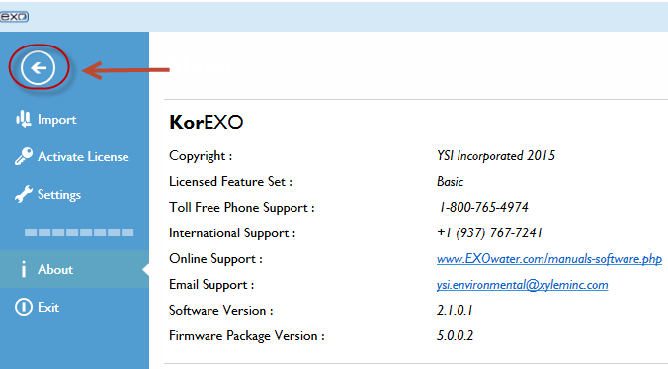

*View Data*

Next view the data from the .bin file. Click on View Recorded Data in the KOR EXO main screen.

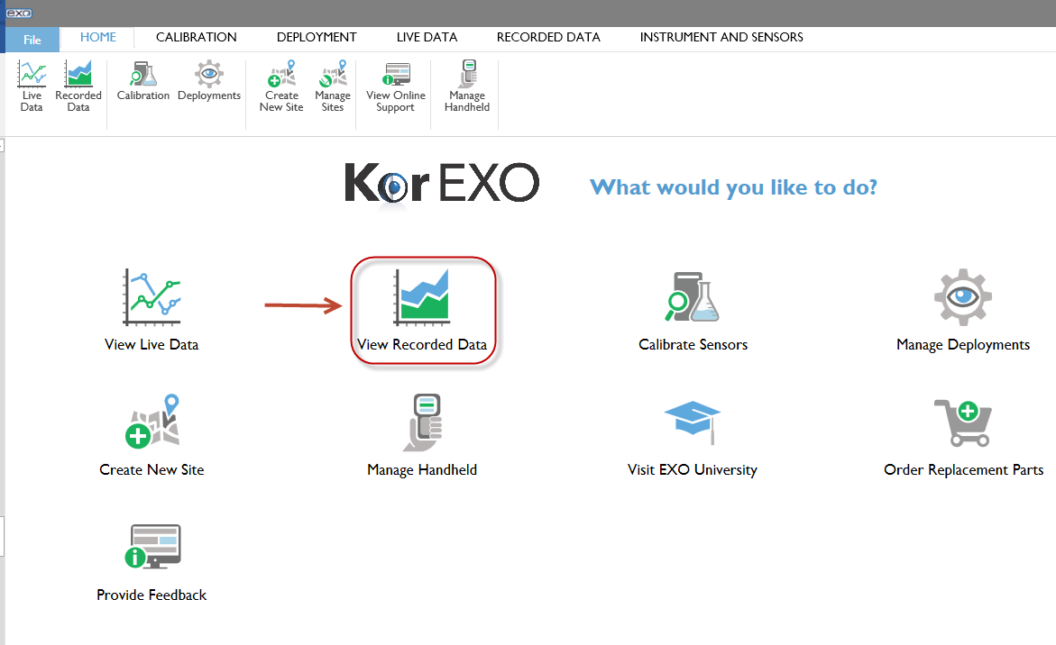

Click Search to view recorded measurement records.

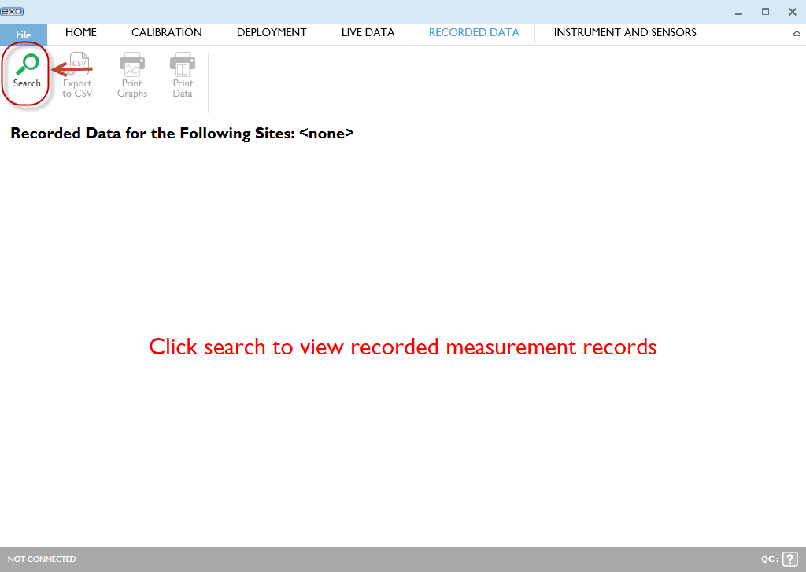

Since you just downloaded the binary files you’d like to view, click the Recently Downloaded check box. Alternatively, you can choose to use other filters to view your files.

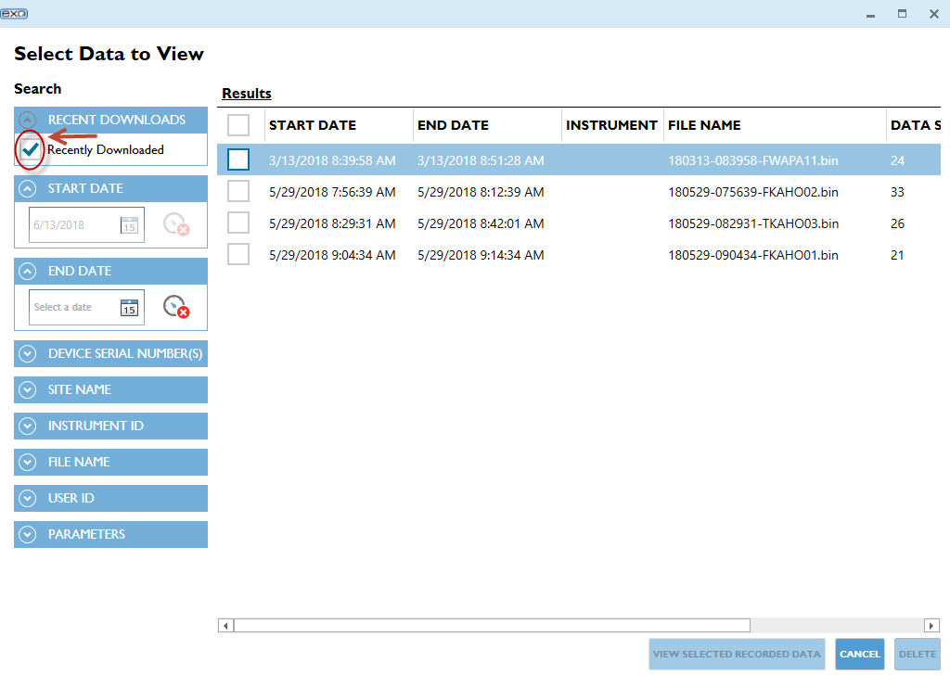

Since the data needs to be exported for each station separately, click on one file at a time to view. After selecting a file, click View Selected Recorded Data.

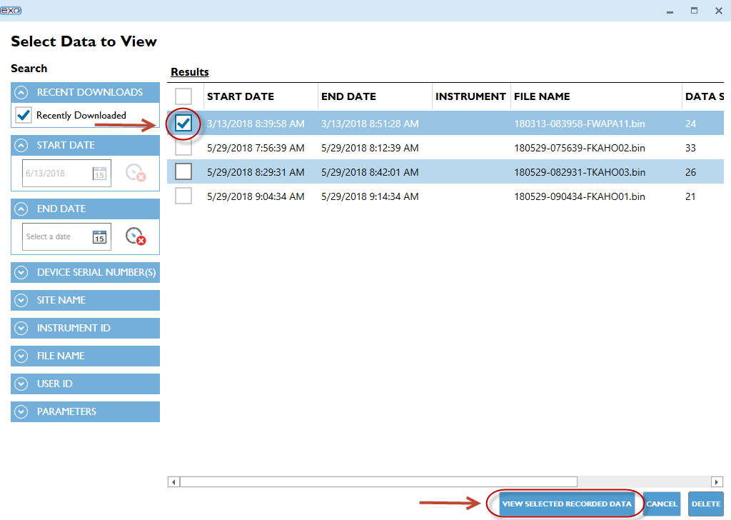

The data from the chosen file will be displayed with the parameters that were chosen in Settings.

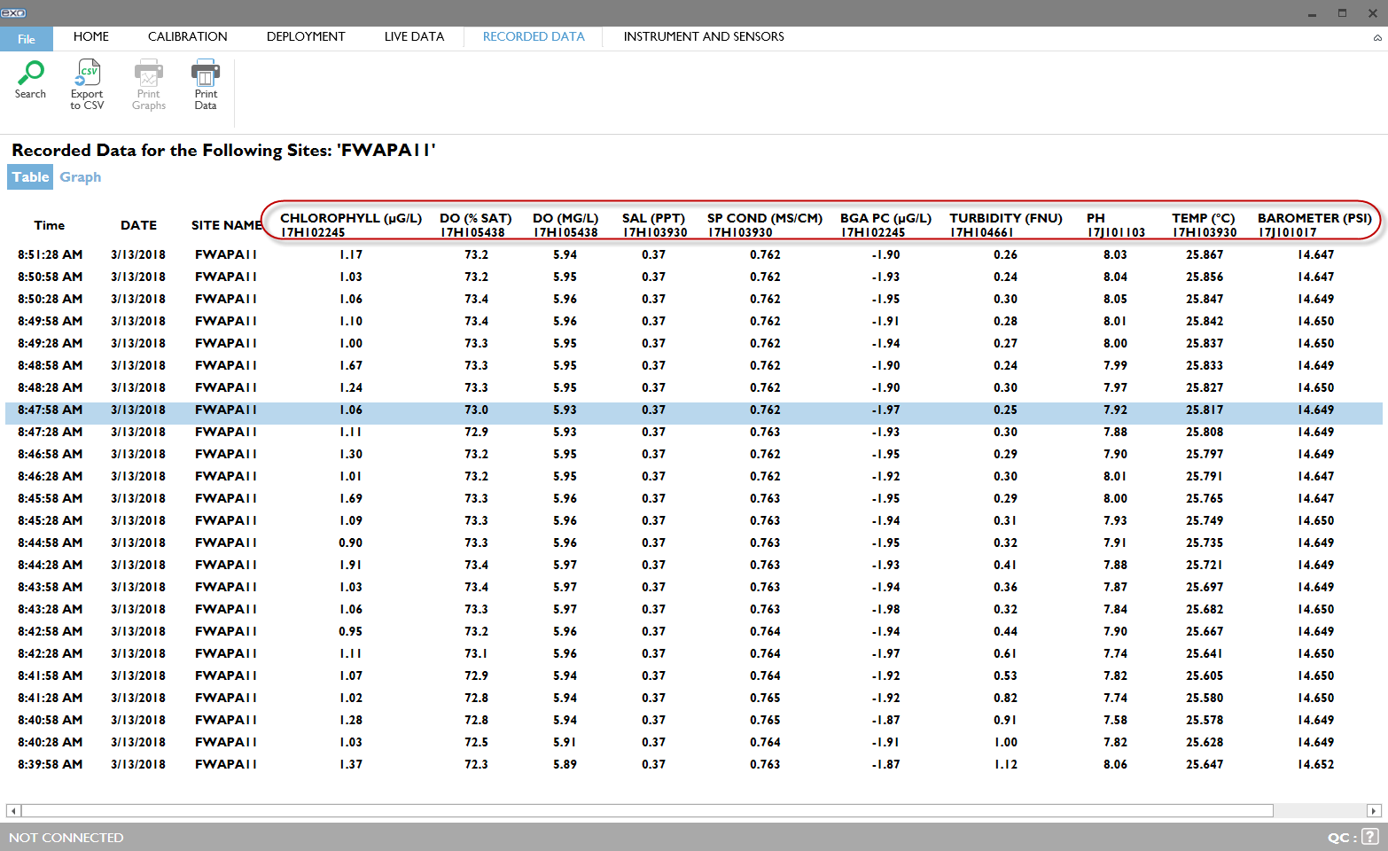

*Export Data*

To export the data, click on the Export to CSV under the File tab. The dialog box will open to the default folder you choose in Settings: I:\vital_signs\13_water_quality\Data\Raw_Data\3_YSI\2018.

Navigate to the correct park folder, and then to the sampling event folder for the raw YSI files. If the folder doesn’t exist, create the folder using the naming convention YYYYMMDD_PARK_[Island]_TYPE_YSI_raw (refer to the section File Locations and Naming Conventions in this SOP or I:\vital_signs\13_water_quality\Data\Database\Database_documentation\SOP_WQ_data_processing_steps.docx for more details).

Save the file using the naming convention YYYYMMDD_Station_ID_YSI_raw. Click Save.

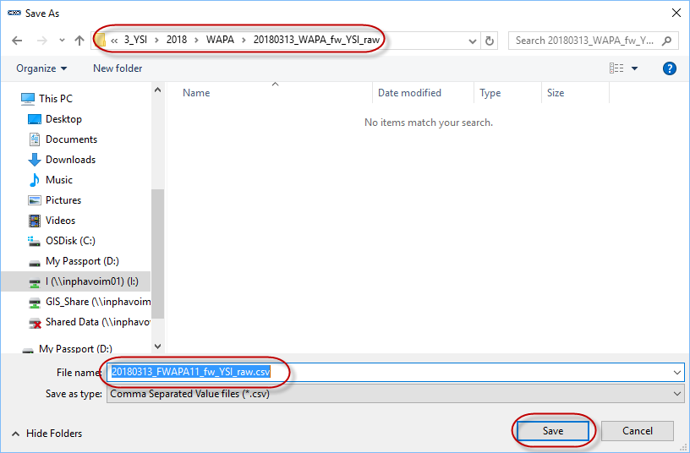

If the data exported successfully, a pop up box will open.

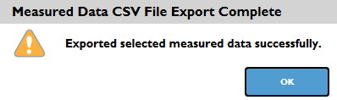

Click OK.

The CSV file will open automatically. The top eight rows need to be deleted in order for the file to be imported into the water quality database. The first row of the CSV file should be the parameters.

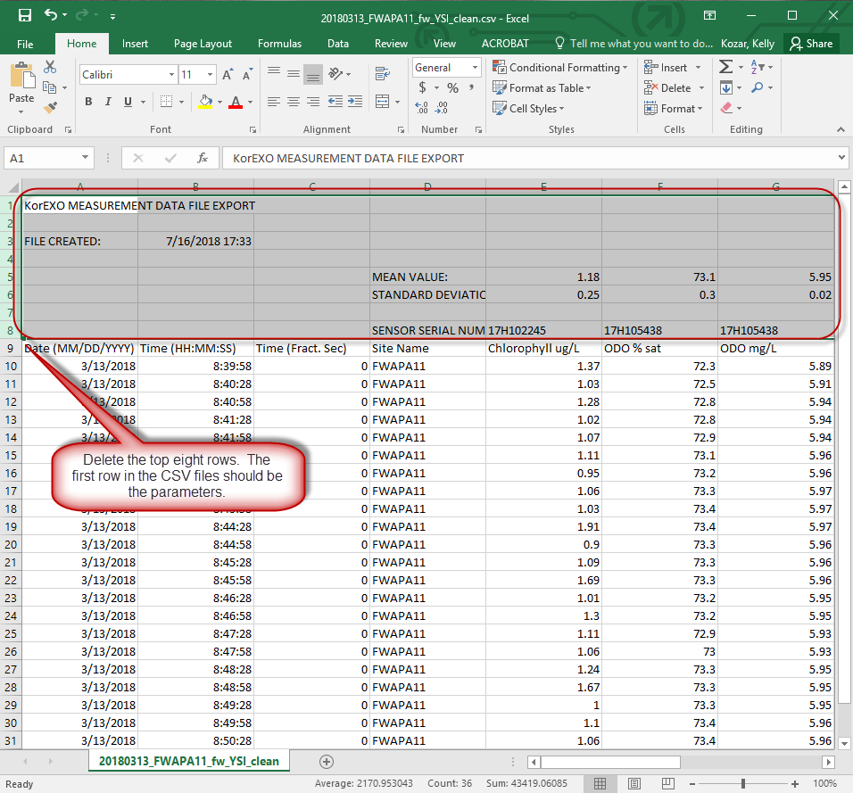

Save the CSV file, keeping the same file name. You will get the Microsoft Excel warning message in the dialog box below. Click “Yes” to keep using that format.

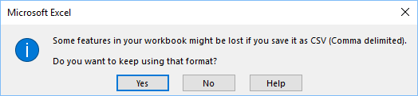

Click Search to view recorded measurement records again. Choose the next file to view results and export data. Repeat the same steps as above until data has been exported for all files.

Follow the steps in the section Data Manipulation at the end of this SOP in order to clip files.

YSI 6600 Data Sonde

Uploading Files

1. Upload unattended files (if any) from the sonde memory to the 650 memory.
   1. Sonde Menu: File: Upload: select file to upload to 650
2. Connect the 650 to PC (usually via serial port), and turn the 650 on. You will need to download an Ecowatch Lite software update from [www.ysi.com](http://www.ysi.com) for it to recognize the 650.
3. Open Ecowatch Lite, and on File: New Connection. This opens a dialogue box that says Terminal-COM1. Ensure that the Baud rate on the bottom left hand side of the screen says 9600.
4. Most serial ports are COM1, but COM2 or COM3 may also work for your computer. Check that the Ecowatch:Comm:Settings match the COM port settings.
5. On the 650, go to File: Upload to PC. Select the file you want to upload. Each file needs to be uploaded separately.
6. The files are automatically saved in C:MyDocuments:YSI:EcoWatchLite:data (.dat files). Open each file in Ecowatch Lite to be sure the upload was successful.
7. Back-up the .dat files, then they can be deleted off the sonde and 650. On the 650 Main menu go to File: Delete all files. Note there is no option to delete only certain files all files must be deleted.

Parameter arrangement and file exporting

Parameters should be arranged in a certain order (in Ecowatch Lite) before exporting the data as a text file. Currently, there are 3 file types with parameters arranged as follows:

* 1. **‘Attended’ –** Freshwater streams, Anchialine Pools, and Wetland field sites
     1. The 650 was connected during data logging, data was stored on the 650, file includes barometric pressure (BP) reading
     2. “Date”,”Time”,”Temp”,”SpCond”,”Salinity”,”pH”,”ODO%”,”Chlorophyll”,”Turbidity+”,”BP”,”ODO Conc”

“M/D/Y”,”hh:mm:ss”,”C”,”mS/cm”,”ppt”,””,”%”,”ug/L”,”NTU”,”psi”,”mg/L”

* 1. **‘Unattended with depth’ –** Marine field sites
     1. Unattended sample, launched with 650 but deployed without 650 attached, data logged to sonde, sonde has depth sensor
     2. “Date”,”Time”,”Temp”,”SpCond”,”Salinity”,”pH”,”ODO%”,”Chlorophyll”,”Turbidity+”,”ODO Conc”,”Depth” “M/D/Y”,”hh:mm:ss”,”C”,”mS/cm”,”ppt”,””,”%”,”ug/L”,”NTU”,”mg/L”,”m”
  2. **‘Unattended without depth’** – usually for extended stream deployments
     1. Unattended sample, launched with 650 but deployed without 650 attached, data logged to sonde, sonde does not have depth sensor
     2. “Date”,”Time”,”Temp”,”SpCond”,”Salinity”,”pH”,”ODO%”,”Chlorophyll”,”Turbidity+”,”ODO Conc” “M/D/Y”,”hh:mm:ss”,”C”,”mS/cm”,”ppt”,””,”%”,”ug/L”,”NTU”,”mg/L”

Ecowatch Lite Instructions (Windows 7, 64-bit computers)

**Adjust Parameter Order in Ecowatch Lite**

1. Open the .dat file in Ecowatch Lite
   1. File > Open > choose .dat file > click Open

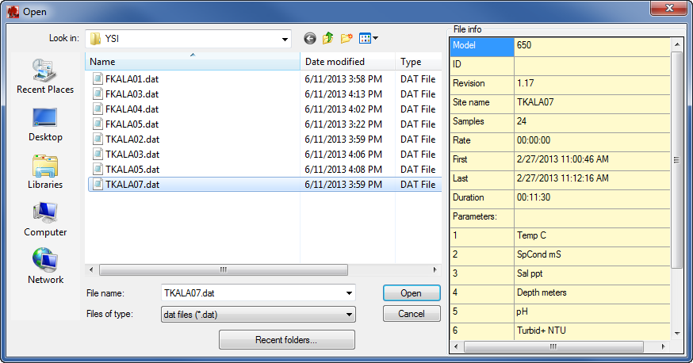

1. Set the Default parameter view
   1. Separate Date and Time
      1. Parameters > Separate Date/Time
      2. Make sure that Separate Date/Time is checked in Parameters

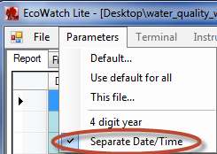

* 1. Parameters > Default
     1. Choose parameters from the Available column if they are not already in the Selected column.
     2. To rename the parameter name and units to the correct naming format necessary for importing the data into the database, use the ellipse button on the right of the parameter label.
     3. Use the up and down arrow buttons to move the parameters into the correct order.

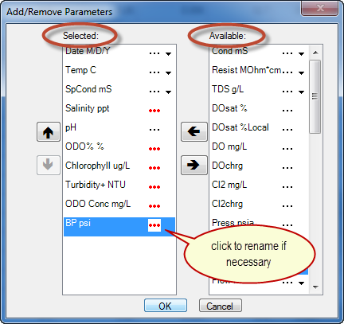

1. If a parameter is not showing up in the Report screen once you have set the default, you may need to add the parameter from the file.
   1. Parameters > This file…
   2. Find the parameter in the available column, and move it to the Selected column
      1. In the example, ???24 is Barometric Pressure (BP; determined from Ecowatch, in which it showed up automatically as BP, and from the values).
      2. Move from Available to Selected
      3. Rename as BP with units as psi
      4. Move to correct position

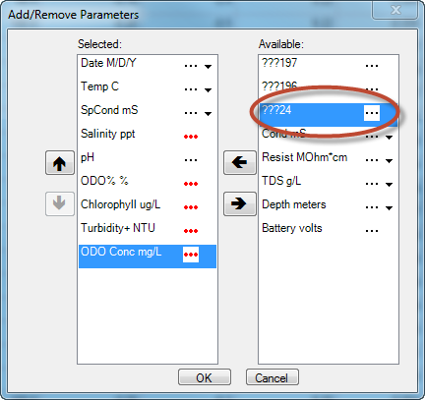

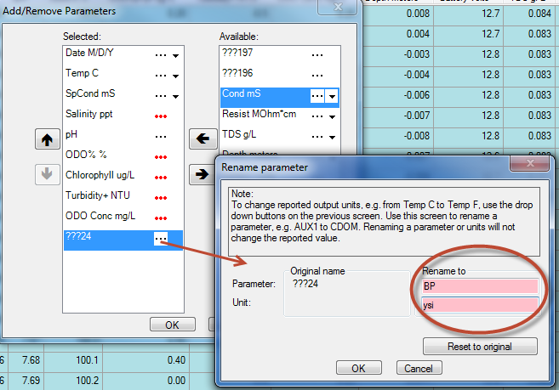

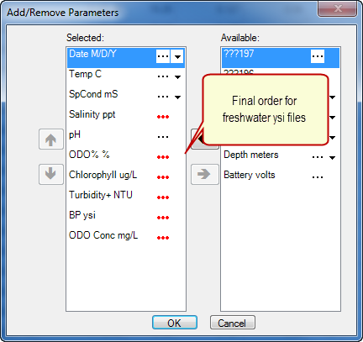

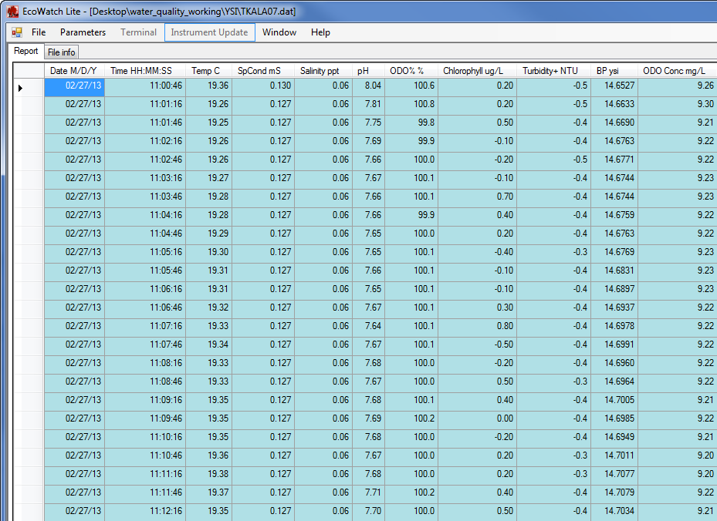

Export CSV File from Ecowatch Lite

In Ecowatch lite, the data cannot be exported as a text file. It can be exported as a CSV, then changed to a text file that can then be imported into the water quality database.

1. File > Export > CSV
   1. The default folder is the same folder that the .dat file is in. This is where the CSV should be saved.
2. Make a copy of the newly created CSV file and paste it the same folder.
3. Rename the copy of the file to a text file.
   1. For example, TKALA07 - Copy.csv to TKALA07.txt
   2. A warning will come up saying the file may become unusable, click “Yes” to change the file name.
   3. Open the new text file to confirm it is formatted correctly
      1. There should be double quotes around the parameter names and units, and before the start of each record.

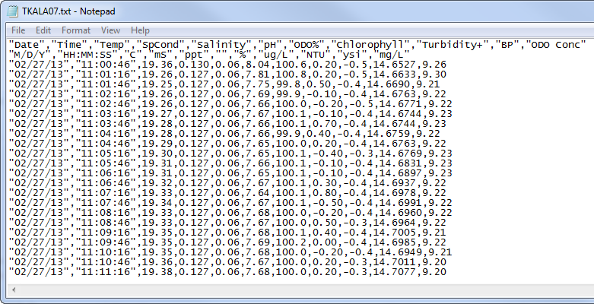

Data Manipulation

Marine files require ‘clipping’ of individual site data from the full day/ multiple days of readings in the text file. Refer to the site sampling times on field datasheets, and ‘clip’ the appropriate section of data from the ‘raw’ text or csv file (which includes data from the entire day). Save the clipped section with the individual site name. (NOTE: Site data can also be extracted and saved separately with the Ecowatch tools. Be sure to save a back-up of the original file if using this method!)

Once the files have been cleaned up, follow the instructions below in File Locations and Naming Conventions for the ‘raw’ and ‘clean’ files. Refer to I:\vital_signs\13_water_quality\Data\Database\Database_documentation\SOP_WQ_data_processing_steps.docx for more details.

File Locations and Naming Conventions

1. There will be a folder for each park for each sampling year in the folder: I:\vital_signs\13_water_quality\Data\WQ_Raw_Data\ 3_YSI\YYYY\PARK\
   1. YYYY = sampling year
   2. PARK = 4 letter park code
2. In this folder, create 2 subfolders for the YSI files for a sampling event
   1. ‘**YYYYMMDD_PARK_[Island]_TYPE_YSI_raw** ’ - Ecowatch files, raw text files
      1. Folder Naming Convention:
         1. YYYYMMDD = the date stamp (YYYYMMDD) is the first date of the sampling date where there are multiple dates sampled.
         2. PARK = 4 letter park code
         3. [Island] – For NPSA only, add the island the sampling was conducted on
            1. Tut – Tutuila
            2. Tau – Tau
            3. Ofu - Ofu
         4. TYPE = between PARK and YSI, put the type of water quality site these YSI files are for.
            1. ap = anchialine pool
            2. bb = brackish body
            3. fw = freshwater (for KALA, the freshwater sampling event folder will include FKALA05_bb site as well, even though it’s a brackish site)
            4. gw = groundwater
            5. mr = marine
      2. Contains the first version of data exports (both .dat files and .bin files.)
         1. Move the raw files that have been exported from Ecowatch Lite or KOR-EXO to this folder
         2. Short names (5 letter site names) are fine for .dat and .bin files.
      3. Contains the exported files from Ecowatch Lite or KOR-EXO
         1. Save the exported .csv file (Ecowatch Lite) or .txt file (KOR-EXO) to this folder
      4. Rename ‘raw’ .csv or .txt files to “YYYYMMDD_Station_ID_YSI_raw”.
         1. The date stamp for YSI files is the actual date the station was sampled. There may be multiple dates sampled within the folder.
         2. For fixed stations, the Station ID should match the Station ID in the database. This includes the station type
            1. For example, FKALA01_mr, FHALE01_fw, FKAHO01_ap, FPUHE01_bb, etc.
         3. For temporary stations, use the same format as for fixed stations. This will not match what is in the database, but the temporary station names do not need to include date stamp in station name for YSI files since the date is part of the file name.
            1. For example, TKALA05_mr, THALE01_fw, TKAHO04_ap, etc.
         4. For marine files, include a suffix with depth (i.e. ‘sur’ (for surface) or ‘btm’ (for bottom)).
         5. For YSI6600 files, if not already done, change the extension from .csv to .txt to convert to text file. This will not corrupt the file, so disregard any warning messages.
   2. ‘**YYYYMMDD_PARK_[Island]_TYPE_YSI_clean** ’ - clean text or .csv files for database importing
      1. Folder Naming Convention:
         1. YYYYMMDD = the date stamp (YYYYMMDD) is the first date of the sampling date where there are multiple dates sampled.
         2. PARK = 4 letter park code
         3. [Island] – For NPSA only, add the island the sampling was conducted on
            1. Tut – Tutuila
            2. Tau – Tau
            3. Ofu - Ofu
         4. TYPE = between PARK and YSI, put the type of water quality site these YSI files are for.
            1. ap = anchialine pool
            2. bb = brackish body
            3. fw = freshwater (for KALA, the freshwater sampling event folder will include FKALA05_bb site as well, even though it’s a brackish site)
            4. gw = groundwater
            5. mr = marine
      2. Copy the renamed raw .txt (6600) or.csv (EXO2) files to this clean folder.
         1. Rename the raw .txt or.csv file to clean
            1. Change from “YYYYMMDD_Station_ID_YSI_**raw**” to “YYYYMMDD_Station_ID_YSI_**clean**”
      3. Contains only text or .csv files with the following modifications (made manually):
         1. Marine text or .csv files should be ‘clipped’ to only include a single site per file (see Data Manipulation above).
         2. The data within each file should be reviewed. Readings that were taken prior to deployment into the water resource or after removal from the water, or were recorded while the instrument was stabilizing (usually the first 1-2 readings) can be removed. Review pH data closely, as it usually takes longest to stabilize.
         3. For files exported from Ecowatch Lite only - There must be one blank line between the header information (parameters/ units) and the data. When the file is imported, if this space is not included in the file, the first line of recordings will be cut-off. (NOTE: When the file is imported, the header is removed from the file).
         4. There should be no spaces after the last digit of data at the end of the text file (if so, delete all spaces after this last digit. If there is a ‘blank line’ of data, there will be an error message when the file is imported.

1. Put a copy the YSI clean folder to the Database folder**:**
   1. I:\vital_signs\13_water_quality\Data\Database\YSI_files
      1. Be sure to import these files to the database and not the YSI files in the WQ_Raw_Data\3_YSI\ folder as the header will be removed upon import.

Importing YSI files into the I&M Water Quality Database

When uploading YSI files into the database, select the correct YSI Model (YSI6600 or YSIEXO2_v2) and the correct file type (Attended, Unattended with depth, and Unattended without depth) from the Import dialog box in the database. Be sure to choose the YSI file in the I:\vital_signs\13_water_quality\Data\Database\YSI_files folder. Details on importing YSI files into the database are covered in section 6.2 Importing Data for Sampling Events in the Database Users Guide (Contact: Kelly_Kozar@nps.gov).